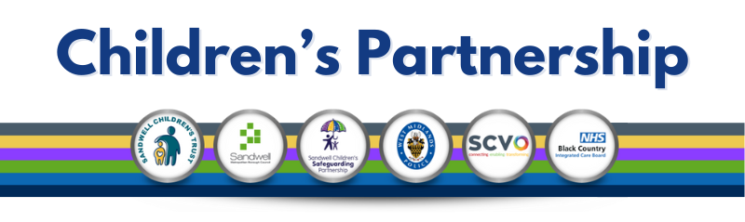

## Autumn Summit

We would like to take a moment to extend our sincere thanks to all our partners who attended the Autumn Summit on Friday, 8th November. We truly appreciate you taking time out of your busy schedules to join us, and we hope the event was as informative for you as it was for us.

We value the feedback you provided and will certainly take it into consideration as we plan for next year's event. We are committed to continuously improving and ensuring that the Summit remains a valuable and engaging experience for all involved.

A post Summit pack is being put together and will be sent out to all that attended in due time.

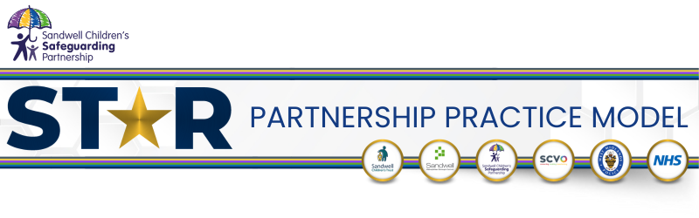

We’ve received common feedback that some agencies are still seeking further information on the ST*R Partnership Practice Model. To help clarify, we’ve shared a clip from a recent roadshow [https://youtu.be/-vLDWGCiLso](https://links-1.govdelivery.com/CL0/https:%2F%2Fyoutu.be%2F-vLDWGCiLso/1/0100019396882ebe-0f1f0904-7c62-405c-8b98-570aa45ccb01-000000/RBqio2Oyd-Uz5STmSTWfpZjtOkzkJJRsnIfi1wld-dE=382). We encourage you to watch it, and should you have any additional questions, please feel free to reach out to our ST*R Project Manager, Lehanne Gordon ([Lehanne_Gordon@sandwellchildrenstrust.org](mailto:Lehanne_Gordon@sandwellchildrenstrust.org)).

## New Resources

**Practitioner Booklet**

We’re excited to share that the feedback from our partnered focus groups has been collated, and the ST*R Partnership Practice Model leads are working to refine the Practitioner Booklet. This comprehensive document will be submitted for sign off to January’s 25 operational meeting, in the hopes that it will be available for practitioners and professionals in the new year. A huge thank you to all our practitioner participants for their valuable input – we couldn’t have done it without you!

**Children's Booklet**

Our task-and-finish group has been formed for the development of the Children’s Booklet, and we’ll be seeking support from local schools, Voice Forum, SEN forums, and home-educated groups within the Sandwell area.

**Parent/Carer Booklets**

Barnardo’s hosted the first Parent and Carer Consultation event on 13th November, aimed at ensuring we capture the voice of our Sandwell parent/carers. They will also be hosting drop-in sessions at family hubs, which we encourage you to share with your parent/carer forums. More details on dates will be shared soon.

## Training Opportunities

The Sandwell Children’s Safeguarding Partnership learning and development team is calling for passionate individuals to join our Train the Trainer pool. We currently have a few spaces available for the Trauma-Informed Practice training pool. If you’re interested in joining our team, please contact [scsp_training@sandwell.gov.uk](mailto:scsp_training@sandwell.gov.uk).

Thank you again for your continued support and collaboration. If you have any questions or would like to discuss any of the above in more detail, don’t hesitate to get in touch.