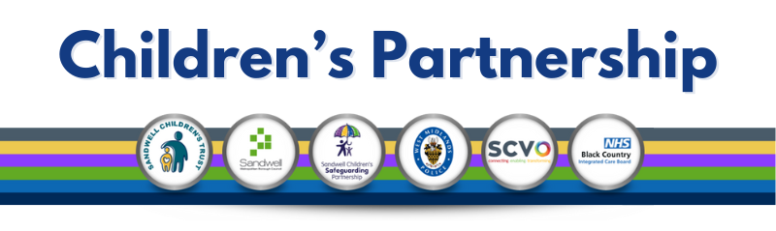

## Roadshows/Autumn Summit

Over the past few weeks, we’ve had the pleasure of hosting a series of successful roadshows, bringing together key members of our partnership to share insights and ideas. As we approach the final leg of this series, we wanted to remind you that **our last roadshow** will be held on **17th October 2024**.

If you haven’t had the chance to attend one of our sessions yet, there’s still time to register! Don’t miss out on this final opportunity to engage with your Sandwell peers and participate in valuable discussions.

To book your place for the final roadshow, simply send an email to: [scsp_training@sandwell.gov.uk](mailto:scsp_training@sandwell.gov.uk)

Additionally, we are excited to announce that our **SCSP Autumn Summit** will take place on **Friday, 8th November 2024**. The Summit will feature thought leaders, industry experts, and in-depth discussions on the latest trends shaping our sector. This promises to be a key event in our calendar, and we would love for you to join us.

Please register via Eventbrite at:  
[https://www.eventbrite.co.uk/e/scsp-autumn-summit-tickets-1036613919137](https://links-1.govdelivery.com/CL0/https:%2F%2Fwww.eventbrite.co.uk%2Fe%2Fscsp-autumn-summit-tickets-1036613919137/1/01000192708e63b6-80828724-de22-4c71-b4a3-ce9fa7111108-000000/61RMbf_aDbHGc9qWqyH0ZyQSKR8LkqpqWkUJ8SX_o-o=373)

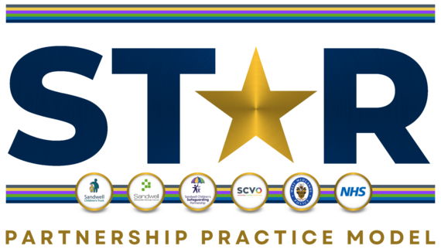

We are pleased to share some exciting updates on the progress of the **ST*R Partnership Practice Model**.

|  |  |  |
| --- | --- | --- |
| New Resources Practitioner Booklet Recently, the SCSP hosted a **ST*R Practice Model lead workshop** where we reviewed the first draft of the **ST*R Partnership Practice Model Practitioner Booklet**. This draft will soon undergo further refinement through **upcoming focus groups**, which will be hosted by each agency. |  | Booklet For Professionals |

## Children’s and Parent/Carer Booklets

We are thrilled to announce that in addition to the Practitioner Booklet, the Partnership will soon be releasing two additional resources:

* A **Children’s Booklet**, designed to provide information tailored for younger audiences children and young people .
* A **Parent’s/Carer’s Booklet**, aimed at supporting families and carers in understanding the ST*R Practice Model and how it benefits their children and children they care for.

These resources will help increase engagement and provide further clarity around our practice model for both professionals and families.

All agencies are working together to promote the ST*R Partnership and generate as much exposure as possible. The **roadshows** have been an excellent opportunity for us to engage with practitioners across the Sandwell area. With the release of the three booklets, we are confident this will further enhance understanding and clarity among practitioners, children, and families.

## Integrated Front Door

We are committed to promoting and enhancing understanding of the Integrated Front Door (IFD) approach across the Partnership. As part of this effort, we continue to emphasize that the IFD includes all the help and support available to families, ranging from universal support to multi-agency assistance (see Slide 1 below). We are also reinforcing that, wherever appropriate, these levels of response should be explored prior to contacting MASH.

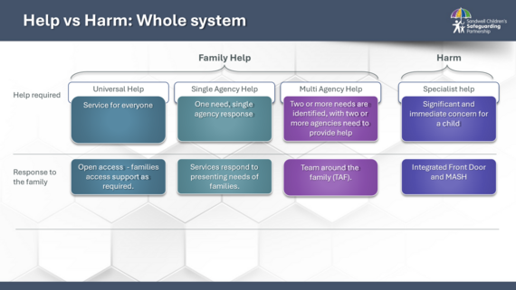

This important message is being cascaded through service-specific meetings, SCSP Roadshows, and training sessions. By doing so, we aim to ensure that all practitioners across the Partnership are well-equipped to understand and access the full spectrum of support available to families.

A key aspect of our practice is fostering relationship and strength-based conversations with families. These conversations are crucial for securing agreements for support and are reshaping the way practitioners engage with families. By focusing on strengths, we are building trust and encouraging collaboration in providing the right help at the right time.

We have received positive feedback from our partnership workforce, who have expressed greater clarity on the full range of support available when concerns arise for a baby, child, or young person (see Slide 2 below). This feedback highlights the growing confidence among practitioners in navigating different avenues of help and support, further strengthening our collective approach.

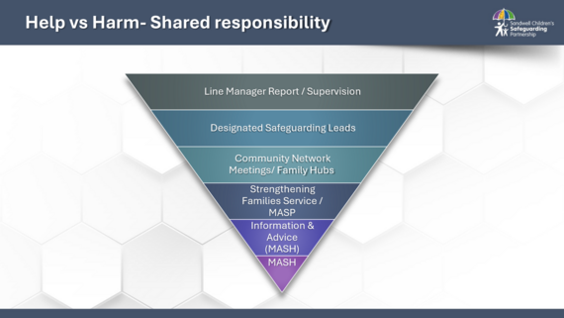

## ****Upcoming MASH Telephone Line****

We are excited to announce that we anticipate the launch of a **dedicated MASH telephone line** in December 2024. While we await the final confirmation of the launch date, we wanted to give you advance notice of this important development. Once the date is confirmed, we will keep the Partnership updated and initiate a 2-3 week countdown with reminders going out regularly.